Aim: TypeScript Student Registration System

1. Classes and Objects
A class in TypeScript is a blueprint for creating objects. It encapsulates data (properties) and behavior (methods). In this project, we use classes to represent a "Person" and a "Student".

2. Inheritance
Inheritance allows a class (subclass) to acquire the properties and methods of another class (superclass). Here, the Student class extends the Person class, demonstrating the "is-a" relationship (a Student is a Person).

3. Access Modifiers
Access modifiers control the visibility of class members:
● Public: Accessible from anywhere (e.g., Student name/age).
● Private: Accessible only within the class it is defined (e.g., Roll Number for security).
● Protected: Accessible within the class and its subclasses (e.g., internal Person identifiers).

Code (index.html):

<!doctype html>
<html lang="en">
<head>
<meta charset="UTF-8" />
<meta
name="viewport"
content="width=device-width, initial-scale=1.0, user-scalable=yes"
/>
<title>TypeScript Student Registration System</title>

</head>
<body>
<div class="app-container">
<div class="header">
<h1>Student Registration System</h1>
</div>

<div class="dashboard">
<div class="registration-panel">
<h2 class="panel-title">Register new student</h2>
<form id="studentForm">
<div class="form-group">
<label> Full name</label>
<input
type="text"
id="studentName"
placeholder="e.g., Priya Sharma"
autocomplete="off"
required
/>
</div>
<div class="form-group">
<label> Student ID</label>
<input
type="text"
id="studentId"
placeholder="e.g., S12345"
autocomplete="off"
required
/>
</div>
<div class="form-group">
<label> Email address</label>
<input
type="email"
id="studentEmail"
placeholder="student@example.com"
autocomplete="off"
required
/>
</div>
<div class="form-group">
<label> Course</label>
<select id="studentCourse">
<option value="Computer Science">
Computer Science
</option>
<option value="Business Administration">
Business Administration
</option>
<option value="Engineering">Engineering</option>
<option value="Mathematics">Mathematics</option>
<option value="Design">Design</option>
</select>
</div>
<button type="submit" class="btn">Add Student</button>
</form>
</div>

<div class="student-list-panel">
<h2 class="panel-title">
Registered Students
<span id="studentCountBadge" class="stats-badge"
>0</span
>
</h2>
<div id="studentsContainer">
<div class="empty-message">
No students yet. Register your first student!
</div>
</div>
</div>
</div>
</div>
<script src="index.ts"></script>
</body>
</html>

Code (index.ts)

class StudentManager {
#students = [];

#container;

#countBadge;

constructor(containerId, badgeId) {
const container = document.getElementById(containerId);
const badge = document.getElementById(badgeId);

if (!container)
throw new Error(
`Container element with id "${containerId}" not found`,
);
if (!badge)
throw new Error(`Badge element with id "${badgeId}" not found`);

this.#container = container;
this.#countBadge = badge;
}

getAllStudents() {
return [...this.#students];
}

addStudent(studentData) {
const duplicate = this.#students.some(
(s) =>
s.studentId.toLowerCase() ===
studentData.studentId.toLowerCase(),
);
if (duplicate) {
return {
success: false,
message: `Student with ID "${studentData.studentId}" already exists.`,
};
}

const newId = `student_${Date.now()}_${Math.random().toString(36).substring(2, 8)}`;

const newStudent = {
id: newId,
name: studentData.name.trim(),
studentId: studentData.studentId.trim(),
email: studentData.email.trim(),
course: studentData.course,
};

this.#students.push(newStudent);
this.#renderStudentList();
return {
success: true,
message: "Student added successfully!",
};
}

removeStudentById(internalId) {
const initialLength = this.#students.length;
this.#students = this.#students.filter(
(student) => student.id !== internalId,
);
const removed = initialLength !== this.#students.length;
if (removed) {
this.#renderStudentList();
}
return removed;
}

#renderStudentList() {
const count = this.#students.length;
this.#countBadge.textContent = String(count);

if (count === 0) {
this.#container.innerHTML = `<div class="empty-message"> No registered students yet. Use the form to add.</div>`;
return;
}

const cardsHtml = this.#students
.map((student) => {
const safeName = this.#escapeHtml(student.name);
const safeStudentId = this.#escapeHtml(student.studentId);
const safeEmail = this.#escapeHtml(student.email);
const safeCourse = this.#escapeHtml(student.course);

return `
<div class="student-card" data-student-id="${this.#escapeHtml(student.id)}">
<div class="student-info">
<div class="student-name">${safeName}</div>
<div class="student-details">
<span> ${safeStudentId}</span>
<span> ${safeEmail}</span>
<span> ${safeCourse}</span>
</div>
</div>
<button class="remove-btn" data-remove-id="${this.#escapeHtml(student.id)}" aria-label="Remove student"> Remove</button>
</div>
`;
})
.join("");

this.#container.innerHTML = cardsHtml;

const removeButtons = this.#container.querySelectorAll(".remove-btn");
removeButtons.forEach((btn) => {
btn.addEventListener("click", (event) => {
event.stopPropagation();
const internalId = btn.getAttribute("data-remove-id");
if (internalId) {
const removed = this.removeStudentById(internalId);
if (removed) {
this.#showToast(
`Student removed successfully`,
"#10b981",
);
} else {
this.#showToast(`Could not remove student`, "#ef4444");
}
}
});
});
}

#escapeHtml(str) {
if (!str) return "";
return str
.replace(/[&<>]/g, function (m) {
if (m === "&") return "&amp;";
if (m === "<") return "&lt;";
if (m === ">") return "&gt;";
return m;
})
.replace(/[\uD800-\uDBFF][\uDC00-\uDFFF]/g, function (c) {
return c;
});
}

#showToast(message, bgColor = "#3b82f6") {
let toast = document.getElementById("dynamicToast");
if (!toast) {
toast = document.createElement("div");
toast.id = "dynamicToast";
toast.style.position = "fixed";
toast.style.bottom = "20px";
toast.style.left = "50%";
toast.style.transform = "translateX(-50%)";
toast.style.backgroundColor = bgColor;
toast.style.color = "white";
toast.style.padding = "12px 24px";
toast.style.borderRadius = "40px";
toast.style.fontWeight = "500";
toast.style.fontSize = "0.9rem";
toast.style.zIndex = "9999";
toast.style.boxShadow = "0 10px 20px rgba(0,0,0,0.2)";
toast.style.backdropFilter = "blur(4px)";
toast.style.transition = "opacity 0.2s";
document.body.appendChild(toast);
}
toast.style.backgroundColor = bgColor;
toast.textContent = message;
toast.style.opacity = "1";
setTimeout(() => {
toast.style.opacity = "0";
setTimeout(() => {
if (toast.parentNode) toast.remove();
}, 300);
}, 2000);
}
}

class RegistrationFormController {
constructor(manager, formId) {
this.#manager = manager;
const formElement = document.getElementById(formId);
if (!(formElement instanceof HTMLFormElement)) {
throw new Error(
`Form with id "${formId}" not found or not a form element.`,
);
}
this.#form = formElement;

const nameInput = document.getElementById("studentName");
const studentIdInput = document.getElementById("studentId");
const emailInput = document.getElementById("studentEmail");
const courseSelect = document.getElementById("studentCourse");

if (!nameInput || !studentIdInput || !emailInput || !courseSelect) {
throw new Error("Required form fields missing from DOM");
}

this.#nameInput = nameInput;
this.#studentIdInput = studentIdInput;
this.#emailInput = emailInput;
this.#courseSelect = courseSelect;

this.#attachEvent();
}

#attachEvent() {
this.#form.addEventListener("submit", (event) => {
event.preventDefault();
this.#handleAddStudent();
});
}

#handleAddStudent() {
let name = this.#nameInput.value.trim();
let studentId = this.#studentIdInput.value.trim();
let email = this.#emailInput.value.trim();
let course = this.#courseSelect.value;

if (name === "") {
this.#showFieldError("Please enter student name", this.#nameInput);
return;
}
if (studentId === "") {
this.#showFieldError(
"Student ID is required",
this.#studentIdInput,
);
return;
}
if (email === "") {
this.#showFieldError("Email address is required", this.#emailInput);
return;
}

const emailPattern = /^[^\s@]+@([^\s@.,]+\.)+[^\s@.,]{2,}$/;
if (!emailPattern.test(email)) {
this.#showFieldError(
"Please enter a valid email (e.g., name@domain.com)",
this.#emailInput,
);
return;
}

const idPattern = /^[a-zA-Z0-9_-]+$/;
if (!idPattern.test(studentId)) {
this.#showFieldError(
"Student ID can only contain letters, numbers, underscores or hyphens.",
this.#studentIdInput,
);
return;
}

const result = this.#manager.addStudent({
name,
studentId,
email,
course,
});

if (result.success) {
this.#nameInput.value = "";
this.#studentIdInput.value = "";
this.#emailInput.value = "";

this.#courseSelect.selectedIndex = 0;
this.#clearFieldHighlights();

this.#showFloatingMessage(`${result.message}`, "#3b82f6");
} else {
this.#showFloatingMessage(
`${result.message || "Duplicate or invalid data"}`,
"#ef4444",
);

if (result.message?.includes("already exists")) {
this.#highlightField(this.#studentIdInput);
}
}
}

#showFieldError(message, inputElement) {
this.#showFloatingMessage(message, "#f97316");
this.#highlightField(inputElement);
}

#highlightField(input) {
input.style.border = "2px solid #ef4444";
input.style.backgroundColor = "#fff5f5";
setTimeout(() => {
input.style.border = "";
input.style.backgroundColor = "";
}, 2000);
}

#clearFieldHighlights() {
[this.#nameInput, this.#studentIdInput, this.#emailInput].forEach(
(inp) => {
inp.style.border = "";
inp.style.backgroundColor = "";
},
);
}

#showFloatingMessage(msg, bgColor) {
let toast = document.getElementById("dynamicToast");
if (!toast) {
toast = document.createElement("div");
toast.id = "dynamicToast";
toast.style.position = "fixed";
toast.style.bottom = "20px";
toast.style.left = "50%";
toast.style.transform = "translateX(-50%)";
toast.style.padding = "12px 24px";
toast.style.borderRadius = "40px";
toast.style.fontWeight = "500";
toast.style.fontSize = "0.9rem";
toast.style.zIndex = "9999";
toast.style.boxShadow = "0 8px 20px rgba(0,0,0,0.2)";
toast.style.transition = "opacity 0.2s";
toast.style.color = "white";
document.body.appendChild(toast);
}
toast.style.backgroundColor = bgColor;
toast.textContent = msg;
toast.style.opacity = "1";
setTimeout(() => {
toast.style.opacity = "0";
setTimeout(() => {
if (toast.parentNode && toast.id === "dynamicToast") {
if (toast.style.opacity === "0") toast.remove();
}
}, 300);
}, 2200);
}
}

document.addEventListener("DOMContentLoaded", () => {
try {
const studentManager = new StudentManager(
"studentsContainer",
"studentCountBadge",
);

const formController = new RegistrationFormController(
studentManager,
"studentForm",
);

} catch (error) {
console.error("Initialization error:", error);
const container = document.getElementById("studentsContainer");
if (container) {
container.innerHTML = `<div class="empty-message" style="color:red;">System failed to load: ${error.message}</div>`;
}
}
});

Output:

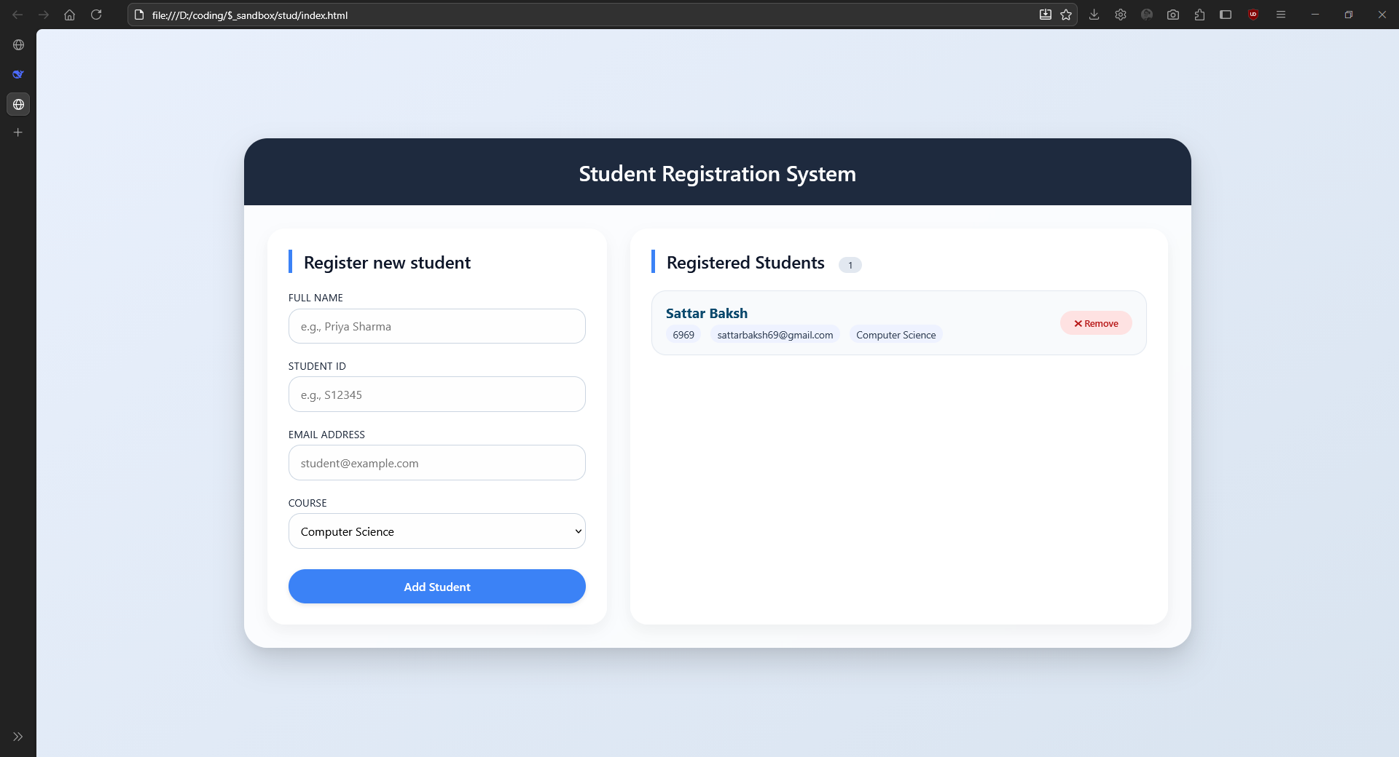

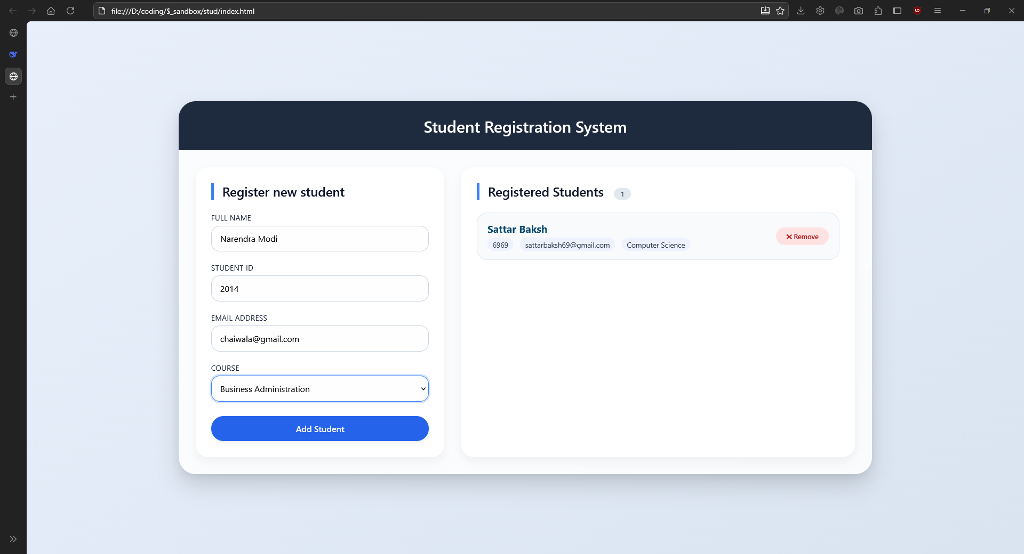

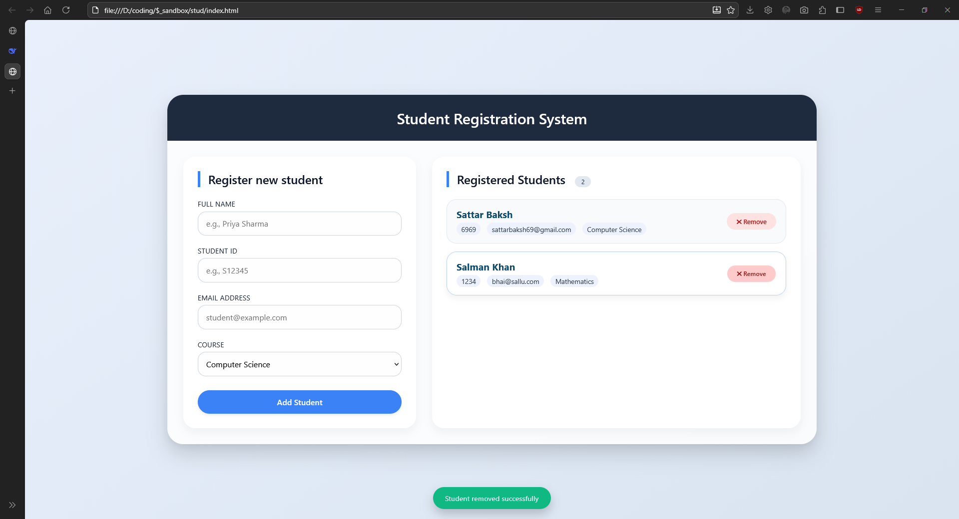

Conclusion:
The application successfully demonstrates the use of TypeScript's strictly typed nature and OOP features. By using inheritance, we reduced code redundancy, and access modifiers ensured better data encapsulation, making the registration system robust and easy to scale.

